# Title:

An emission scenario weighting framework to improve the use of scenario ensembles of opportunity

Authors:   
Hamish Beath1, Chris Smith2,3, Jarmo Kikstra1,3,4, Mark Dekker5,6, Matthew J. Gidden3,7, Joeri Rogelj1,3,4

# Affiliations:

1Centre for Environmental Policy, Faculty of Natural Sciences, Imperial College, London, United Kingdom

2Department of Water and Climate, Vrije Universiteit Brussel, Brussels, Belgium

3International Institute for Applied Systems Analysis (IIASA), Laxenburg, Austria

4The Grantham Institute for Climate Change and the Environment, Imperial College London, London, United Kingdom

5 PBL Netherlands Environmental Assessment Agency, The Hauge, Netherlands

6Copernicus Institute for Sustainable Development, Utrecht University, Utrecht, Netherlands

7Climate Analytics, Berlin, Germany

# Abstract:

Integrated assessment models (IAMs) produce large ensembles of socioeconomic scenarios that are used profusely in climate change research. Assessments by the Intergovernmental Panel on Climate Change (IPCC), analysis by non-governmental organisations or advice by national climate committees often rely on them to identify mitigation strategies and set climate targets. A limitation of such evidence is the opportunistic nature of scenario ensembles: they are an unstructured, serendipitous collection of evidence. Drawing on concepts from physical climate science and the analysis of ensembles of climate model data, we present a novel approach for the flexible, multidimensional weighting of emission scenario data that accounts for relevance, quality, and diversity. Our illustrative application to the latest IPCC scenario database demonstrates a reduction in dominance of highly represented models and studies, and may indicate more stringent net-zero emission milestones than originally reported. However, our framework only provides a starting point for improving scenario-based climate assessments.

# Keywords:

Integrated Assessment Modelling, climate change, socioeconomics, mitigation, scenarios, bias correction

# Main text:

Since the publication of the IPCC Special Report on Emissions Scenarios1 in 2000, integrated assessment models (IAM) have become central tools for exploring emissions and climate futures in climate research. Despite already being part of the IPCC Third2 and Fourth3 Assessments in 2001 and 2007, it was the IPCC’s Fifth Assessment4, the Special Report on Global Warming of 1.5°C5 (SR1.5) and the IPCC Sixth Assessment6 (AR6) that solidified the use of large scenario ensembles for the assessment of global mitigation strategies. With their expanded use also came an improved understanding and communication of their limitations7,8.

Scenarios that are collected as part of IPCC or other exercises9–11 represent ensembles of opportunity: a serendipitous collection of scenario data that is unstructured7 and in which the scenarios that are ultimately included vary in their purpose, design, comprehensiveness, coverage, quality and other characteristics. One key limitation of the use of large emission scenario ensembles is that shortcomings or biases present in the collected ensemble can be propagated by subsequent secondary analysis7,8. Such biases include dominance of specific models and intercomparison projects, which in turn grouped together can represent a lack of diversity in organisational type, or regional composition [cite papers as recommended by reviewer 3]. Unless adequately corrected for, this could lead to spurious or biased results.

Typical shortcomings or biases in scenario ensembles of opportunity relate to three main issues: scenario relevance, quality, and diversity. Relevance refers to whether a scenario, through the structural properties of the underlying model, its design, and outcome characteristics is relevant to the question that is being investigated by the secondary analysis. This can include the estimated level of global warming avoided by the scenario12, assessments of the feasibility of its described transitions13, or even subjective – but transparently communicated – preferences about technologies or strategies. Quality refers to whether the implementation and execution of the modelling lives up to pre-defined quality standards set out by the secondary analysis. These standards typically refer to technical modelling aspects such as the accuracy of historical data, time resolution, or plausibility of near-term trends and resource use. Diversity, finally, refers to the degree of additional information a scenario communicates compared to other members in the ensemble of opportunity. Not accounting for the latter can result in statistics across a scenario ensemble being too narrow or overconfident towards the results of a single model, modelling team or modelling exercise.

In the past, such issues have been dealt with on an ad-hoc basis. For example, the IPCC SR1.55 checked for the completeness of variables available in scenarios, whether data is reported until 2100, or whether reported historical- or near-future data is consistent with observations9,14. For the assessment of global emission characteristics of pathways aligned with 1.5°C, SR1.5 also excluded 13 scenarios submitted by a single modelling group15 because they included virtually no variation in emissions and their inclusion would have biased descriptive emission statistics. Criteria for including or excluding scenarios depend on context, which explains why these 13 scenarios were still included in the analysis of aspects other than the evolution of emissions in the SR1.5 report. Similar well-informed, but ad-hoc considerations were applied in the latest AR6 mitigation assessment of the IPCC6,8.

Other climate research communities have also grappled with similar issues, and the Earth System Modelling community has established methods to down-weight models based on their similarity to other models16–18, as well as for model quality measured as performance relative to historical observations18,19. In emission scenario ensemble analysis, issues of scenario similarity have been considered20, but as of yet not systematically addressed.

In this paper, we use efforts from various communities16–20 as a starting point to develop and present a scenario-weighting method that addresses issues of scenario relevance, quality and diversity, and provide a systematic approach that unifies and expands on ad-hoc scenario assessment decisions that were made in the past1–6. We apply it to the latest available IPCC AR6 scenario ensemble of opportunity10 to illustrate its use in practice. We discuss the strengths and weaknesses of such an approach, with a view to further research and refinement of the approach.

## A generalised scenario weighting framework

Our starting point takes a generalised view that each scenario in an ensemble of opportunity must be assigned a weight for subsequent analysis. In the past, re-analysis of scenario ensembles would decide to include or exclude scenarios from their analysis, effectively assigning weights of 1 or 0. Here we formalise this step. Each scenario *i* contributing to the assessment and member of the ensemble of opportunity *E* is assigned a generalized weight *gwi*:

where *0 ≤ R(i) ≤ 1* is a measure of how relevant a scenario is to answer a specific question (relevance weighting), *0 ≤ Q(i) ≤ 1* is a metric of scenario quality (quality weighting) and *D(i) >= 1* is a metric of scenario uniqueness (diversity weighting). This ensures *gwi* has a weight between 0 and 1. Scenarios with lower weights are less relevant, of lower quality, or very similar to others, and hence contribute less towards the final statistics of the ensemble. Figure 1 provides a schematic of the framework.

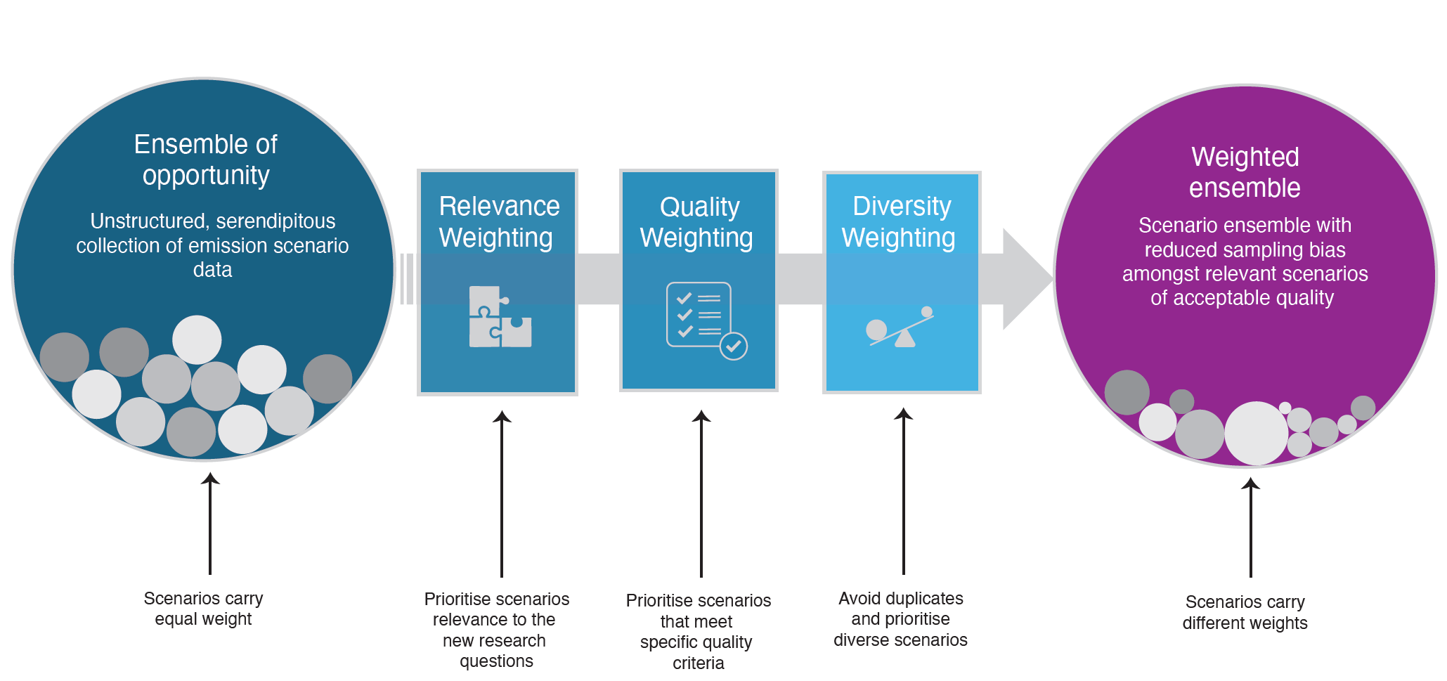

**Figure 1 | A scenario weighting framework for the analysis of scenario ensembles of opportunity.** Schematic showing how the unstructured, serendipitous collection of evidence in a scenario ensemble of opportunity can be translated in a weighted ensemble, accounting for a scenario’s relevance, quality and diversity.

## Relevance weighting

Analysing and re-using scenario data is only sensible once a corresponding research question is defined. A key step in generalized scenario weighting is therefore to define question-specific relevance weights *R(i)* (Eq. 1). This relevance-weighting term *R(i)* can take multiple forms depending on the question being asked. For example, it could be strictly binary such that it is a weighting that includes or excludes scenario *i* based on meeting the question-specific condition *C*:

$$\begin{aligned}R\left(i\right)=\left\{\begin{aligned}1 if C \\ 0 else\end{aligned}\right.\#\left(2\right)\end{aligned}$$

A straightforward example of such a condition is whether a scenario limits global warming to between specific temperature bounds12. This condition is critical if the intention is to explore characteristics in line with keeping global warming well below 2°C or 1.5°C with a specific likelihood12,21,22.

However, binary weighting of scenarios based on their temperature outcome is only fully defensible if uncertainty around a scenario’s climate outcome can be unambiguously quantified with a single probability distribution. This is typically never the case23. Under such conditions, *R(i)* could also take the form of a continuous function. Consider an example with a threshold *ϑ* provided for a given scenario metric *mi*. *R(i)* can be constructed in a way such that scenarios within the threshold are weighted with unity, and scenarios beyond the threshold are weighted based on their distance to the threshold, for example, using a stretched exponential function with scaling factor *α* and stretching exponent *β* to determine the relevance weight:

$$\begin{aligned}R\left(i\right)=\left\{\begin{aligned}1 if m_{i}<ϑ \\ e^{-\left({\left(α.\frac{m_{i}-ϑ}{ϑ}\right)}^{β}\right)} else\end{aligned}\right.\#\left(3\right)\end{aligned}$$

Alternatively, scenarios that are within a defined threshold *ϑ*, could be weighted based on their distance from it. For example, a user may have strict requirements to specific temperature boundaries but may want to apply a risk-based relevance weighting. In this instance, scenarios further from category boundaries achieve a higher,as they are deemed to have a lower risk of breaching the defined temperature threshold.

## Scenario quality weighting

The quality of a scenario is central to consider whether to continue using its information for secondary analysis. However, an assessment of quality is subjective and depends on the research question that is being explored. For example, the accuracy of a scenario’s historical emissions might be important when one aims to understand how emissions relate to global warming targets, while the accuracy of historical energy system capacities might become important in addition if characteristics of the energy transformation are gleaned from these pathways. Alternatively, for specific research questions, quality weighting may be derived from the characteristics or structure of certain models or model types. For example, their treatment of, or omission of, specific technologies of interest. Quality weighting could also be assigned using quantifiable feasibility criteria, obtained from literature or expert judgment or elicitation[cite]. Practically, this could mean excluding or down weighting scenarios with technology pathways or societal changes known to be outside plausible achievability. Therefore, quality weights must be assigned as a function of the question(s) being addressed.

Methods that have earlier been applied to account for climate data projection quality16–19 can be adapted to our new context, by comparing emissions and energy trends in scenarios to recent observations. Scenario quality can be accounted for by implementing a continuous weighting *Qj(i)* between 0 and 1 for each scenario *i*, based on a set of *j* distance criteria *fj(d)* of *k* quality metrics defined between a scenario’s modelled data for a metric (vk,i) and an expert assessments of a set of measures of quality (*Ek*) (Eq. 4).

$$\begin{aligned}Q\left(i\right)=\prod_{j,k}{f_{j}\left(d\left(v_{k,i},E_{k}\right)\right)}\#\left(4\right)\end{aligned}$$

The IPCC SR1.5 and AR6 assessments did not use a formal method of scenario weighting but applied a scenario quality filtering7,8,14,24, with each scenario effectively assigned *Q(i)* = 0 (excluded) or *Q(i)* = 1 (included). For example, SR1.5 excluded scenarios with negative CO2 emissions from agriculture, forestry and other land-use (AFOLU) in 2020 due to the perceived implausibility of AFOLU CO2 emissions becoming negative within two years of the report’s publication7,14. In addition, SR1.5 excluded a further 30 scenarios from its analysis of global and sectorial emissions evolutions (see Table 2.4 and Figure SPM.3 in ref. 5) for having greenhouse gas emissions in 2010 outside the range of historical estimates. Other parts of the report that explore scenario dimensions orthogonal to global and sectorial emissions evolutions, include all scenarios. In both above-mentioned cases, *fj(d)* would take a functional form that returns 1 when a scenario variable in a given year falls inside a set range and zero when not.

## Weighting based on scenario diversity

Scenario diversity is the last dimension in our weighting framework, and provides a metric of distance or proximity between scenarios. It equally requires expert judgment and a clear research question to identify relevant variables. For example, to explore emissions statistics consistent with limiting global warming to a specific level, considering the diversity in scenarios’ emission evolutions could be sufficient. However, to explore questions about the range of energy system configurations compatible with a specific climate goal, another set of variables could be selected for determining that diversity.

We use an adapted version of the method to estimate effective repetitions in Earth System Model projections16,17 that uses a Gaussian function:

$$\begin{aligned}D\left(i\right)=\left(1+\sum_{i'≠i}{exp\left(-\frac{S_{ii'}^{2}}{σ_{S}^{2}}\right)}\right)\#\left(5\right)\end{aligned}$$

where Sii’ is a similarity distance metric between two scenarios *i* and *i'* for a single variable, and is taken as a root-mean-square difference between two time series; and *σS*is the “radius of scenario similarity”17. If two scenarios *i* and *i'* are exactly the same, *Sii’* = 0 and *D(i)* = 2, weighting each model as 1/2. Eq. (5) can be generalised to compare scenario similarity across *N* variables:

$$\begin{aligned}D_{n}\left(i\right)=1+\sum_{n=1}^{N}{\sum_{i'≠i}{b_{n}exp\left(-\frac{S_{ii',n}^{2}}{σ_{S,n}^{2}}\right)}}\#\left(6\right)\end{aligned}$$

where *bn* are relative contributions of each variable to the total diversity weighting that sum to 1 across all variables *n*. Besides selecting *σS,n* for each variable *n*, Equation 6 also requires the selection of the appropriate constants *bn*. The simplest case could be to set *bn* = 1/*N*, but some variables may be more important than others in relative terms (e.g. several variables of the energy system compared to one variable of the food system).

Other ways of defining *D(i)* could also draw on an analysis of the underlying energy model fingerprint of mitigation scenarios25 or alternative ways of conceptualising distance, for example, through principal component analysis.

## Dependencies between weighting applications

Our method uses multiple weights which can interact with one another. For instance, the definition and calculation of quality *Q(i)* and diversity *D(i)* weights is informed by the scope of relevance weights *R(i)* being applied. In addition, quality and relevance can be multidimensional and individual dimensions can be weighted differently. As a result, a set of final scenario weights and the analysis outcomes of the weighted dataset may change based on the scope of the research question being asked. Our weighting method allows this dependency to be communicated in a structured and transparent way.

Consider two analyses of interest. The first interrogates a scenario dataset based on temperature outcomes. In this case, *Q(i)* may comprise weights based on proximity to historical emissions inventories. However, for a research question focused on investments needed to achieve a given temperature limit, *Q(i)′* would additionally weight scenarios based on their historical investment and near-term investment outcomes. In this case, *Q(i)* differs from *Q(i)′* and secondary analysis outcomes will reflect these different research demands.

## Application to IPCC AR6 database

To illustrate the application and usefulness of our weighting framework, we apply it to the scenarios included in the IPCC AR6 Scenario Database10 and look at the influence on some of the key scenario assessment outcomes of the AR66. We focus this illustrative application on scenarios that limit warming to 1.5°C with no or limited overshoot (IPCC category C1), the subset of C1 scenarios also reaching net zero greenhouse gas (GHG) emissions over the course of the 21st century22 (IPCC category C1a), and scenarios that return warming to 1.5°C after a high overshoot (IPCC category C2). We apply binary question-specific relevance weights R(i) to select the desired scenarios, although we apply alternative continuous relevance weighting approach in Supplementary Results 1. We apply a continuous quality weighting,, based on the IPCC AR6 vetting procedure24 (see Methods). Diversity weighting D(i) considers the similarities between scenarios in four key dimensions (emissions, economy, mitigation strategy, and energy) and a total of 15 variables (Methods Table 1). . However, due to correlations between variables, this is reduced to 8 variables used in the main results presented here (see Methods). We primarily focus on diversity weighting in these results, as it represents the most complex dimension. We consider it in separation from our continuous quality weighting to ensure interpretability. The outcomes presented here represent one set of weighting inputs; further examples and their impact on the ensemble are discussed in the Supplementary Information.

## Illustrative reweighting reveals sensitivity of climate action benchmarks

Applying question-specific relevance, quality, and diversity weighting to the IPCC AR6 database reveals a range of final weights across scenarios (Fig. 2a). Higher-emission scenarios in the IPCC AR6 scenario database (IPCC categories C3 and higher) show less relative diversity than mitigation scenarios in the C1 and C2 categories and hence see a larger number of scenarios with lower weights. This feature can be understood when considering that the scenario compilation by IPCC AR6 aimed to explore diverse mitigation futures. Quality weights (Fig. 2d) have a spikey distribution, as scenarios from specific intercomparison projects and models have harmonised input data.

Visually, 2050 CO2 emission and peak warming ranges of C1 and C2 show very little change (Figs. 2b, c e & f). For our diversity weighting, there are minor reductions in the median 2050 CO2 emissions for C1 and C1a, with all categories seeing a widening of IQRs and 5th-95th percentile ranges (Fig. 2b). The median peak temperatures barely change for C1 and C1a, with C2 showing a visible reduction; all categories have a widening of interquartile ranges. For quality weighting (Figs 2e & f), the impact on medians varies between temperature categories.



**Figure 2 | Diversity weighting of scenarios available in the IPCC AR6 scenario database. a.** Diversity weights *D(i)* for scenarios per IPCC scenario category; **b.** unweighted and diversity weighted distributions for 2050 CO2; **c.** unweighted and diversity weighted distributions for median peak temperature (MAGICCC); **d** Quality weights *Q(i)* for scenarios per IPCC scenario category; **e.** unweighted and diversity weighted distributions for 2050 CO2  **f.** unweighted and quality weighted distributions for median peak temperature (MAGICCC). For panels b, c e and f, the darker coloured distributions for each temperature represented weighted ones. The wides shaded ranges represent the 5th and 95th percentiles, with the narrow ones the interquartile range. Weighted and unweighted quantiles are computed using the same non-interpolating approach (see Methods).

Looking at other outcomes of our diversity weighting, including net-zero years (Fig. 3a) and the trajectory of certain variables (Fig. 3b-l, Supplementary Figures 2 & 3), some categories and metrics show noteworthy changes. In the scenario category compatible with limiting warming to 1.5°C with no or limited overshoot (C1) the median year of reaching net-zero GHG emissions is advanced by a decade (from 2098 to 2088). For C1a scenarios, representing 1.5°C with no or limited overshoot but with net-zero GHGs by 2100, the net zero GHG date is advanced by three years (2071 to 2068). The scenario category returning warming to 1.5 by 2100 after a high overshoot (C2) the median net-zero GHG date moves earlier, but by less than a year, while the upper quartile reduces by 2 years (from 2084 to 2082). Median net zero CO2 years remain almost identical, with C1 and C1a shifting by less than a year and C2 remaining the same.

For many of the 15 variables reported by all scenarios, changes for our C1 and C2 scenarios are negligible (Supplementary Figures 2 & 3). However, there are visible changes to the timeseries of certain mitigation relevant variables, highlighting where the ensemble is sensitive to diversity weighting. For example, for both C1 and C2 scenarios, the median and upper quartile for carbon capture and storage (CCS) is higher in the second half of the century. In 2070 the median values are 13% and 7% higher for C1 and C2 respectively.

The data suggest that reweighting has greater impact where outcomes are widely spread and unevenly distributed. However, this is not automatic e.g., Primary Energy from Gas for C1 scenarios (Fig. 2d) exhibits a wide interquartile range, with the 75th percentile diverging from the median in the second half of the century and little change in the reweighted ensemble. This highlights that the effect also depends on similarity within and across temperature categories in the wider ensemble, and the effective sigma values for determining similarity (Supplementary Results 2).

Whilst only illustrative, these observations indicate that a more balanced consideration of the diversity of the scenario evidence suggests small but measurable changes to climate action benchmarks. Given the observed change in net zero GHG years, the IPCC AR6 scenario assessment would be understood as conservative regarding the mitigation action compatible with stringent mitigation targets aligned with the Paris Agreement.

We explore a range of further diversity weighting procedures and their impact on climate action benchmarks in the Supplementary Results 2. This highlights which changes broadly persist regardless of weighting inputs (e.g., reduction in net zero GHG years, CCS use increase), and others that vary depending on the choice of weighting variables (e.g., Primary energy from Gas).

We show the impact of our continuous quality weighting on mitigation variables in Supplementary Figures 5 and 6.



**Figure 3 | Key assessment quantities in diversity weighted and unweighted scenario category ranges from the IPCC AR6 scenario database. a.** Net zero CO2 and greenhouse gas (GHG) years; **b.** Carbon sequestration from carbon capture and storage for C1; **c.** Carbon sequestration from carbon capture and storage for C2 **d. & e,** Primary Energy from Gas timeseries for C1 and C2 respectively; **e & h**, Primary Energy from Nuclear timeseries for C1 and C2 respectively; **f & I,** Carbon Price timeseries for C1 and C2 respectively. Our plots show data from three scenario categories: scenarios limiting warming to 1.5°C with no or limited overshoot (IPCC AR6 category C1) n=97, the subset of these scenarios also reaching net zero GHG emissions in the second half of the century (IPCC AR6 category C1a) n=50, and scenarios returning warming to below 1.5°C in 2100 after a high (0.1–0.3°C) overshoot (IPCC AR6 category C2) n=133. Individual scenarios are shown as dots. Violins show unweighted and weighted distributions, respectively, which are distinguished through lighter and darker areas. Dashed and dotted lines in the plots indicate key distribution statistics as defined by the legend in panel **a**. For timeseries plots, the coloured shaded areas represent the interquartile range of the reweighted distribution, with grey shaded areas representing the unweighted interquartile range. The coloured dashed lines represent weighted medians, whilst black dashed lines represent unweighted medians, as shown in the legend in panel h. Weighted and unweighted quantiles are computed using the same non-interpolating approach (see Methods).

## Exploring robustness

It is well-established that the behaviour of IAMs is to a large degree determined by their model framework logic, model structure and input assumptions26,27. Equally, model intercomparison studies use harmonised scenario design assumptions which dominate key scenario insights28. Understanding whether insights or diagnosed scenario characteristics are robust across model typographies, structures and scenario design assumptions is therefore important. Jack-knife resampling allows the estimation of bias of a test statistic and has been applied to scenario ensembles of opportunity in the past.29 It was implemented here to quantify the robustness of our insights. Such a test calculates how outcomes *Vd* vary across the ensemble of opportunity *E* when iteratively removing scenarios according to each instance *d* in resampling dimension *D* (e.g., removing specific modelling frameworks or intercomparison studies, or specific types of models such as recursive-dynamic and intertemporal optimisation models).

We carry out two jack-knife resampling tests to see how outcomes are affected by the diversity reweighting of scenarios in the ensemble. In the first resampling test, we assess the sensitivity to unbalanced contributions by model frameworks, and in the second, the sensitivity to contributions by specific projects (Fig. 4, and Supplementary Tables S1 and S2). Our results show that our illustrative diversity weighting changes sensitivity of the removal of projects or model frameworks to ensembles statistics. There are ensemble statistics where jackknife ranges are narrower under our weighted examples, such as 5th and 25th percentiles for net zero GHG years for C1 scenarios (Fig 4a). This indicates that these earlier shifts from diversity weighting are robust.

Some ensemble statistics show greater variability post-weighting. For example, for C1, the median net zero GHG for project and model, and the 95th percentile of net zero CO2 year for project show wider ranges than their unweighted counterparts (Fig 4a, b). This indicates greater sensitivity to model or project composition, and less stability in the weighted ensemble. However, there are nuances when interpreting wider ranges around ensemble statistics. For C1 GHG medians, the lower bound of the project-based jackknife values occurs when removing the ENGAGE project. ENGAGE is the most prominent project for C1 and sees a reduced share in the weighted ensemble (Fig 5b). In this instance, the reduced lower bound value for the weighted project jackknife median net-zero GHG year reflects the higher diversity weights of scenarios from other smaller projects.



**Figure 4 | Interplay between weighting of scenario ensembles and jack-knife resampling outcomes. a.** Net zero GHG years; **b.** Net zero GHG years CO2. Statistics are documented in the figure legend. For each statistic of the unweighted and the weighted ensemble, the jackknife resampling illustrates the potential variation in the estimators. The jack-knife resampling based on model framework iteratively excludes each respective larger modelling framework group as reported in the IPCC AR6 database. The resampling based on project iteratively excludes each respective contributing project or individual study. See Supplementary Tables S1 and S2 for a list. Both weighted and unweighted quantiles are computed using the same non-interpolating approach (see Methods).

## Diversity weighting impact on model and project dominance

Accepting that scenario similarity is due in part to commonality of model or intercomparison study, one would expect differences between unweighted and diversity weighted proportions of each. We explore this for our illustrative diversity weighting, showing small but measurable differences in the shares of projects and models (Figs 5b, d). In our examples, the share of the most dominant model framework (REMIND) falls, reducing from 42.2% to 39.6% for C1 scenarios, and 33.1% to 32.4% for C2 scenarios in the unweighted and weighted ensembles, respectively. Applying the Herfindahl-Hirschman Index (HHI), a common indicator used for measuring concentration or dominance within a dataset, we see for model framework, model type and project dominance is reduced for both C1 and C2 categories (Supplementary Figure 11). For model framework and model type, there is an 8-9% improvement for C1 and C2, and for project, an 11% improvement for C1, and a 6% improvement for C2. We explore the impact on these outcomes of a range of alternative inputs to our diversity scheme in Supplementary Results 4.

Next, examining the diversity weighting applied to specific scenarios, the representation of models and projects appears to influence which scenarios achieve high or low weights. All scenarios in the highest 10 scenarios diversity weighted scenarios for both C1 and C2 scenarios originate from a model framework and/or project with low representation (Figs 5a &c). Likewise, for the lowest 10 scenarios, these are dominated by scenarios originating from either a project and model with high representation, or in many instances both. Examining groups of similar scenarios in top and bottom 10, we can see that there are near identical scenarios being down weighted. The bottom five scenarios (Fig. 5c) for C2 originate from MESSAGE (second most prevalent model for C2) and are variants with 50 Gt CO2 differences (400-650) in carbon budgets. In our top 10 for C2, there are three scenarios which are also carbon budget variants; however, these come from the AIM model framework (3rd least prevalent for C2) and have wider carbon budget differences (100Gt CO2).



**Figure 5 | Insights into how scenarios diversity weighted according to model frameworks and projects. a.** connectedrank plot showing C1 scenarios grouped by model (left ranking), diversity weight (central ranking) and project (right ranking). **b** the unweighted and weighted proportions of each project, model type and model framework for C1 scenarios; **c,** equivalent connected rank plot from panel **a**, but for C2 scenarios; d, stacked bars showingthe unweighted and weighted proportions of each project, model type and model framework for C2 scenarios. For the rank plots (panels **a** & **c**), in the left and right ranks, scenarios are grouped with the largest model/project at the bottom. Thicker more visible connection lines are shown the for scenarios in the highest or lowest 10 scenarios by diversity weighting. For the stacked bars (panels **b** and **d)** the lighter shaded bars are unweighted, and the darker shaded bars are diversity weighted. Only the 8 largest shares shown, with other grouped together as “Other”, as visible on the key.

## Reweighting for an improved scenario assessment

This paper presents a weighting framework as a tool to support scenario assessment, designed to be simple and transparent. In our illustrative application of the framework, we explored changes to climate action milestones, and whether it corrects for oversampling of prominent models and intercomparison studies. Whilst the findings our of our illustrative are by no means conclusive, they indicate that reweighting for diversity may lead to a strengthening of certain climate action milestones. Our sensitivity analysis indicates that some changes e.g., earlier net zero GHG years for C1 scenarios are maintained across a range of diversity weighting inputs. The diversity weighting procedure reduces the dominance of prominent models and intercomparison studies; with this finding being robust to a range of sensitivities (Supplementary Results 4).

The framework could be applied to explore further dimensions. Scenario quality or relevance weighting could be used to integrate questions around sustainable development within pathway assessments, for example, with practical limits being suggested for biomass or carbon-dioxide removal as part of a the broader United Nations Sustainable Development Agenda5,31,32. It could also be used to explore questions that account for present-day and future feasibility of scenario pathways across multiple dimensions13,33. Finally, although not illustrated in this paper, reweighting of scenario ensembles can also be useful to improve methods that derive relationships from scenario ensembles, such as for the completion of missing species of greenhouse gas emissions34.

Our weighting framework, offers promise,but isIts flexibility allows it to be applied the specific research questions of the user. However, e judgmentexistsinterpretation ofIn this paper, we explore how some of these expert judgments might influence outcomes. Although flexibility of our framework is a strength, proliferation of weighting approaches within the scenario assessment literature could lead to reduced accessibility and transparency. It is therefore vital that there is clear and consistent reporting of applied weightings and justification of their underlying expert judgments. Acknowledging this, the structured nature of the framework can help to ensure the necessary expert judgment is well-guided and transparent.

Moreover, transparency is of critical importance: scenario data have a range of applications, including those where there may be interests in presenting information in a particular way [cite legal example?]. Without a clear framework and best-practice guidance, re-weighting scenario ensembles could facilitate parties with interests to present ensemble statistics in a way that supports their preferred narrative.

It is common practice for scenario ensembles to be used to calculate headline statistics, rather than considering the intricacies of their composition [cite celine’s perspective paper]. Our reweighting framework aims to improve the robustness of ensemble statistics, allowing the user to remove redundancy, and apply tailored quality and relevance criteria. However, it does not provide a tool to identify gaps in the explored solution space. It is important to acknowledge that even after reweighting, scenario ensembles are incomplete, and there is a danger that reweighting may produce an overconfidence in ensemble statistics, which should be treated with caution [cite peters et al 2023]. A critical reflection therefore still needs to accompany its use.

Regarding diversity weighting, as similar scenarios are down-weighted, a balance must be struck between accounting for repeated instances of scenarios that are fundamentally similar, whilst retaining useful information from areas in which they differ. Scenarios that push the boundaries of conventional thinking and are less similar to more traditional modelled pathways, including emerging efforts to implement circular economy and degrowth storylines or those that focus on low energy demand35,36 are likely to be weighted higher and contribute more to category statistics under a weighted assessment. The drawback of this is that potential novel and emerging scenario approaches might over-emphasise scenarios with technologies at the boundaries of realism. Indeed, diversity weighting in isolation could incentivise the creation of such scenarios in unintended ways. There is a need to explore extremes and novel approaches, but not without practical consideration of feasibility. This highlights the importance of careful consideration of all three aspects of the weighting framework that jointly cover aspects of relevance, quality and diversity.

The role of experts in the assessment of the scenario literature will, therefore, remain as important as ever. We here present a first approach to account for scenario similarity and feasibility that can contribute to a larger toolbox of improved methods for scenario assessment.

## Methods

Here we provide the weighting specifications for the illustrative application of the framework to the IPCC AR6 database10. Integrating expressions for all weighting components, the application-specific scenario weighting equation becomes:

$$\begin{aligned}gw_{i}=\frac{R\left(i\right).Q\left(i\right)}{D\left(i\right)}=R\left(i\right).Q\left(i\right)/\left(1+\sum_{n=1}^{N}{\sum_{i'≠i}{b_{n}exp\left(-\frac{S_{ii',n}^{2}}{σ_{S,n}^{2}}\right)}}\right)\#\left(7\right)\end{aligned}$$

#### Relevance Weighting

For analysis of scenarios that limit global warming to 1.5°C with no or limited overshoot (IPCC AR6 category C1), or scenarios that return warming to 1.5°C after a high overshoot (IPCC AR6 category C2), respectively, we apply binary question-specific relevance weights *R(i)* that select scenarios with the specific global warming characteristics as defined in IPCC AR66.

And separately:

$$\begin{aligned}R_{C2}\left(i\right)=\left\{\begin{aligned}1, P(dT_{21st century}>1.5°C)>67\% &&&&&∧P(dT_{2100}<1.5°C)>50\% & \\ 0, else\end{aligned}\right.\#\left(9\right)\end{aligned}$$

C1a scenarios are a subset of C1 scenarios in which net GHG emissions reach zero levels in the second half of the century.

#### Quality Weighting

We test a continuous quality weighting *Q(i)*, adapted from the IPCC AR6 procedures and reported in Table 11 in ref. 24 (reproduced in Supplementary Table S3). For each quality criterion,, that specified a range, we use the distance of the modelled value, for each scenario from the reference value,,normalising by the interquartile range,, of the scenarios



We then use a Guassian function to produce the continuous weight,, for each criterion,:



This yields a weight of 1 when there is perfect agreement with the reference value. We treat each criterion evenly and combining to give a single quality weighting:



In our application of the weighting procedure, we apply it only to vetted scenarios adhering to specific temperature outcomes (see relevance weighting). In practice we are therefore only applying it to scenarios that to meet other vetting criteria that do not provide an acceptable range.

#### Diversity Weighting

Diversity weighting *D(i)* accounts for variations in 15 variables across four key dimensions (emissions, economy, mitigation strategy, and energy, Methods Table 1). These 15 variables are part of the minimum data requirement for a scenario to be considered as part of the IPCC AR6 ensemble and therefore available for each scenario. The illustrative variable weights *bn* for each variable are a subjective choice and here chosen to put equal weights on each of the four key dimensions. Sub-weighting of the variables in each group attempts to limit the overall influence of variables that are similar in nature and could bias the total, or puts weight on more important variables. For example, in the Energy category, the six Primary Energy variables combined are worth the same as the single variable of Final Energy. In the Emissions category, the aggregate weighting of all non-CO2 emissions variables equals that of CO2, recognising that CO2 is the primary anthropogenic driver of climate change37.

Although not applicable here, scenarios that do not report all variables can also be included by rescaling coefficients *bn* for the variables that are available. This rescaling is first achieved within each variable group, or across all remaining groups if one variable group would end up having no reported variables. The sum of *bn* is always unity.

Acknowledging the subjectivity in our variable weighting, we also explored using only energy variables, as well only emissions variables from our selection (Supplementary Results 2). To account for correlation between variables, we adjusted our variable weights using a correlation matrix and hierarchical clustering (Supplementary Methods 1). This results in a set of ‘correlation adjusted’ variable weights, with a reduced number of 8 variables utilised following correlation assessment and clustering. We adopt an even weighting across the variables as we preserve emphasis on originally higher weighted variables in selection of our representative cluster variables (see Supplementary Methods 1 & Table 1). We present our correlation adjusted weights in the main paper but also show results from our full set of variables in Supplementary Results 2.

Our conceptual choice of *σS,n* (radius of similarity) between two scenarios is guided by expert judgment and should be seen as an informed yet illustrative choice rather than a conclusive one. We define *σS,n* as the root mean square difference between different IAMs running the same SSP-RCP combination available from ref. 9 using 10-year timesteps from 2020 to 2100. We explore a range of values between the minimum and maximum of the SSP-RCP model differences, selecting a value that achieves a high median spread in diversity weights across our variables, whilst ensuring a relatively even impact across all variables (Supplementary Results 2). For no-policy, no-mitigation or “business-as-usual” scenarios, we remove the Mitigation group variables from determining the distances of *σS,n* as these are zero by definition in these scenarios.

#### Calculation of weighted quantiles

Quantiles are calculated without interpolation. Reported quantile values are the lowest scenario values equal to or above the quantile. When applying to weighted distributions, quantiles are calculated using the same approach, but rather than scenarios having an equal weight in the distribution, scenarios contribute according to its assigned weight. Therefore, the cumulative sum of weights is used to identify the quantile threshold.

**Table 1 | Variable for estimation of scenario similarity or diversity.** The 15 variables used from the IPCC AR6 Database10 to determine the scenario similarity. For each variable the importance weighting $b_{n}$ assigned to each is shown (equation 6) along with the *radius of scenario similarity $σ_{S, n}$.* The group that each variable applies to is shown, with each group having a total weight of 1/4.

|  |  |  |  |  |
| --- | --- | --- | --- | --- |
| **Variable** | $b_{n}$**expert** |**correlation adjusted** | $$σ_{S, n}$$ | **Group** |
| CO2 Emissions | 1/8 | 1/8 | 2.75 GtCO2 yr-1 | Emissions |
| CH4 Emissions | 1/24 | 0 | 31.2 MtCH4 yr-1 |  |
| N2O Emissions | 1/24 | 1/8 | 0.898 MtN2O yr-1 |  |
| Sulphur Emissions | 1/24 | 0 | 8.48 MtSO2 yr -1 |  |
| Consumption | 1/8 | 1/8 | $41664 bn (2010) | Economy |
| GDP (PPP) | 1/8 | 1/8 | $3983 bn (2010) |  |
| Carbon Capture & Storage | 1/8 | 1/8 | 2811 MtCO2 yr-1 | Mitigation |
| Carbon Price | 1/8 | 1/8 | $19.9 (2010) |  |
| Primary Energy: Oil | 1/48 | 0 | 35.7 EJ yr-1 | Energy |
| Primary Energy: Gas | 1/48 | 0 | 36.7 EJ yr-1 |  |
| Primary Energy: Coal | 1/48 | 0 | 28.5 EJ yr-1 |  |
| Primary Energy: Nuclear | 1/48 | 1/8 | 9.74 EJ yr-1 |  |
| Primary Energy: Biomass | 1/48 | 0 | 18.1 EJ yr-1 |  |
| Primary Energy: Non-Biomass Renewables | 1/48 | 1/8 | 23.7 EJ yr-1 |  |
| Final Energy | 1/8 | 0 | 40.7 EJ yr-1 |  |

## Acknowledgments

H.B. acknowledges funding from the Hitachi-Imperial Centre for Decarbonisation and Natural Climate Solutions. C.J.S. was supported by a NERC/IIASA collaborative research fellowship (NE/T009381/1). J.S.K. was supported by the Natural Environment Research Council under grant agreement NE/S007415/1. M.J.G. was supported by funding from the European Research Council (ERC) under the European Union’s Horizon 2020 research and innovation programme (GENIE – grant agreement No 951542). J.R. was supported by the European Union’s Horizon 2020 research and innovation programme (ESM2025 – grant agreement No 101003536 and PROVIDE – grant agreement No 101003687).

## References

1. Nakicenovic, N. & Swart, R. *IPCC Special Report on Emissions Scenarios*. (Cambridge University Press, Cambridge, United Kingdom, 2000).

2. Morita, T. *et al.* Greenhouse Gas Emission Mitigation Scenarios and Implications. in *Climate Change 2001: Mitigation. A Report of Working Group III of the Intergovernmental Panel on Climate Change* (eds. Chadwick, M. & Parikh, J. K.) 115–166 (Cambridge University Press, Cambridge, UK, 2001).

3. Fisher, B. *et al.* Issues related to mitigation in the long term context. in *Climate Change 2007: Mitigation. Contribution of Working Group III to the Fourth Assessment Report of the Inter-governmental Panel on Climate Change* (eds. Metz, B., Davidson, O. R., Bosch, P. R., Dave, R. & Meyer, L. A.) 169–250 (Cambridge University Press, Cambridge, UK, 2007).

4. Clarke, L. *et al.* Assessing Transformation Pathways. in *Climate Change 2014: Mitigation of Climate Change. Contribution of Working Group III to the Fifth Assessment Report of the Intergovernmental Panel on Climate Change* (eds. Edenhofer, O. et al.) 413–510 (Cambridge University Press, Cambridge, United Kingdom and New York, NY, USA, 2014).

5. Rogelj, J. *et al.* Mitigation pathways compatible with 1.5°C in the context of sustainable development. in *Global Warming of 1.5 °C: an IPCC special report on the impacts of global warming of 1.5 °C above pre-industrial levels and related global greenhouse gas emission pathways, in the context of strengthening the global response to the threat of climate change, sustainable development, and efforts to eradicate poverty* (eds. Flato, G., Fuglestvedt, J., Mrabet, R. & Schaeffer, R.) 93–174 (IPCC/WMO, Geneva, Switzerland, 2018).

6. Riahi, K. *et al.* Mitigation pathways compatible with long-term goals. in *IPCC, 2022: Climate Change 2022: Mitigation of Climate Change. Contribution of Working Group III to the Sixth Assessment Report of the Intergovernmental Panel on Climate Change* (eds. Shukla, P. R. et al.) (Cambridge University Press, Cambridge, UK and New York, NY, USA, 2022). doi:10.1017/9781009157926.005.

7. Huppmann, D., Rogelj, J., Kriegler, E., Krey, V. & Riahi, K. A new scenario resource for integrated 1.5 °C research. *Nat. Clim. Change* **8**, 1027–1030 (2018).

8. Guivarch, C. *et al.* Using large ensembles of climate change mitigation scenarios for robust insights. *Nat. Clim. Change* **12**, 428–435 (2022).

9. Huppmann, D. *et al.* *IAMC 1.5°C Scenario Explorer and Data Hosted by IIASA*. (Integrated Assessment Modeling Consortium & International Institute for Applied Systems Analysis, 2018). doi:10.22022/SR15/08-2018.15429.

10. Byers, E. *et al.* AR6 Scenarios Database. Zenodo https://doi.org/10.5281/zenodo.5886912 (2022).

11. Nakicenovic, N., Victor, N. & Morita, T. Emissions Scenarios Database and Review of Scenarios. *Mitig. Adapt. Strateg. Glob. Change* **3**, 95–120 (1998).

12. Rogelj, J. *et al.* Emission pathways consistent with a 2°C global temperature limit. *Nat. Clim Change* **1**, 413–418 (2011).

13. Brutschin, E. *et al.* A multidimensional feasibility evaluation of low-carbon scenarios. *Environ. Res. Lett.* **16**, 064069 (2021).

14. Forster, P. *et al.* Mitigation Pathways Compatible with 1.5°C in the Context of Sustainable Development Supplementary Material. in *Global Warming of 1.5 °C: an IPCC special report on the impacts of global warming of 1.5 °C above pre-industrial levels and related global greenhouse gas emission pathways, in the context of strengthening the global response to the threat of climate change, sustainable development, and efforts to eradicate poverty* (World Meteorological Organisation, Geneva, Switzerland, 2018).

15. Liu, J.-Y. *et al.* Socioeconomic factors and future challenges of the goal of limiting the increase in global average temperature to 1.5°C. *Carbon Manag.* 1–11 (2018) doi:10.1080/17583004.2018.1477374.

16. Knutti, R. *et al.* A climate model projection weighting scheme accounting for performance and interdependence. *Geophys. Res. Lett.* **44**, 1909–1918 (2017).

17. Sanderson, B. M., Knutti, R. & Caldwell, P. A Representative Democracy to Reduce Interdependency in a Multimodel Ensemble. *J. Clim.* **28**, 5171–5194 (2015).

18. Brunner, L. *et al.* Reduced global warming from CMIP6 projections when weighting models by performance and independence. *Earth Syst. Dyn. Discuss.* 1–23 (2020) doi:https://doi.org/10.5194/esd-2020-23.

19. Tokarska, K. B. *et al.* Past warming trend constrains future warming in CMIP6 models. *Sci. Adv.* **6**, eaaz9549 (2020).

20. Gütschow, J., Jeffery, M. L., Schaeffer, M. & Hare, B. Extending Near-Term Emissions Scenarios to Assess Warming Implications of Paris Agreement NDCs. *Earths Future* **6**, 1242–1259 (2018).

21. Kikstra, J. S. *et al.* The IPCC Sixth Assessment Report WGIII climate assessment of mitigation pathways: from emissions to global temperatures. *Geosci. Model Dev.* **15**, 9075–9109 (2022).

22. Schleussner, C.-F., Ganti, G., Rogelj, J. & Gidden, M. J. An emission pathway classification reflecting the Paris Agreement climate objectives. *Commun. Earth Environ.* **3**, 1–11 (2022).

23. Nicholls, Z. *et al.* Cross-Chapter Box 7.1: Physical emulation of Earth System Models for scenario classification and knowledge integration in AR6. in *Climate Change 2021: The Physical Science Basis. Contribution of Working Group I to the Sixth Assessment Report of the Intergovernmental Panel on Climate Change* (eds. Masson-Delmotte, V. et al.) (Cambridge University Press, 2021).

24. Guivarch, C. *et al.* IPCC, 2022: Annex III: Scenarios and modelling methods. in *IPCC, 2022: Climate Change 2022: Mitigation of Climate Change. Contribution of Working Group III to the Sixth Assessment Report of the Intergovernmental Panel on Climate Change* (Cambridge University Press, Cambridge, UK and New York, NY, USA, 2022).

25. Dekker, M. M. *et al.* Identifying energy model fingerprints in mitigation scenarios. *Nat. Energy* **8**, 1395–1404 (2023).

26. Kriegler, E. *et al.* Diagnostic indicators for integrated assessment models of climate policy. *Technol. Forecast. Soc. Change* **90, Part A**, 45–61 (2015).

27. Harmsen, M. *et al.* Integrated assessment model diagnostics: key indicators and model evolution. *Environ. Res. Lett.* **16**, 054046 (2021).

28. Rogelj, J. *et al.* A new scenario logic for the Paris Agreement long-term temperature goal. *Nature* **573**, 357–363 (2019).

29. Rogelj, J. *et al.* Zero emission targets as long-term global goals for climate protection. *Environ. Res. Lett.* **10**, 105007 (2015).

30. Dekker, M. M. *et al.* Spread in climate policy scenarios unravelled. *Nature* **624**, 309–316 (2023).

31. Roy, J. *et al.* Sustainable Development, Poverty Eradication and Reducing Inequalities. in *Global Warming of 1.5 °C: an IPCC special report on the impacts of global warming of 1.5 °C above pre-industrial levels and related global greenhouse gas emission pathways, in the context of strengthening the global response to the threat of climate change, sustainable development, and efforts to eradicate poverty* (eds. Krakovska, S., Madruga, R. P. & Sanchez, R.) (World Meteorological Organisation, Geneva, Switzerland, 2018).

32. Deprez, A. *et al.* Sustainability limits needed for CO2 removal. *Science* **383**, 484–486 (2024).

33. Warszawski, L. *et al.* All options, not silver bullets, needed to limit global warming to 1.5 °C: a scenario appraisal. *Environ. Res. Lett.* **16**, 064037 (2021).

34. Lamboll, R. D., Nicholls, Z. R. J., Kikstra, J. S., Meinshausen, M. & Rogelj, J. Silicone v1.0.0: an open-source Python package for inferring missing emissions data for climate change research. *Geosci. Model Dev.* **13**, 5259–5275 (2020).

35. Grubler, A. *et al.* A low energy demand scenario for meeting the 1.5 °C target and sustainable development goals without negative emission technologies. *Nat. Energy* **3**, 515–527 (2018).

36. Millward-Hopkins, J. Inequality can double the energy required to secure universal decent living. *Nat. Commun.* **13**, 5028 (2022).

37. IPCC. Summary for Policymakers. *Climate Change 2021: The Physical Science Basis. Contribution of Working Group I to the Sixth Assessment Report of the Intergovernmental Panel on Climate Change* 3−32 (2021) doi:10.1017/9781009157896.001.

# SUPPLEMENTARY INFORMATION

**Supplementary Table S1 | Entities used for jack-knife resampling along the model group dimension.** Models are identified as in the IPCC AR6 scenario database’s meta data10 and model groups as indicated in this table.

|  |  |
| --- | --- |
| **Model Group** | **Model** |
| AIM | AIM/CGE 2.1 |
| AIM | AIM/CGE 2.2 |
| AIM | AIM/Hub-Global 2.0 |
| C-ROADS | C-ROADS-5.005 |
| COFFEE | COFFEE 1.1 |
| GCAM | GCAM 4.2 |
| GCAM | GCAM 5.3 |
| GEM | GEM-E3_V2021 |
| IMAGE | IMAGE 3.2 |
| MESSAGE | MESSAGE-GLOBIOM 1.0 |
| MESSAGE | MESSAGEix-GLOBIOM 1.0 |
| MESSAGE | MESSAGEix-GLOBIOM_1.1 |
| MESSAGE | MESSAGEix-GLOBIOM_1.2 |
| POLES | POLES ADVANCE |
| POLES | POLES EMF33 |
| REMIND | REMIND 1.7 |
| REMIND | REMIND 2.1 |
| REMIND | REMIND-MAgPIE 1.5 |
| REMIND | REMIND-MAgPIE 1.7-3.0 |
| REMIND | REMIND-MAgPIE 2.1-4.2 |
| REMIND | REMIND-MAgPIE 2.1-4.3 |
| WITCH | WITCH 5.0 |
| WITCH | WITCH-GLOBIOM 3.1 |
| WITCH | WITCH-GLOBIOM 4.4 |

**Supplementary Table S2 | Entities used for jack-knife resampling along the project dimension.** Projects and studies are identified as in the IPCC AR6 scenario database’s meta data10.

|  |
| --- |
| **Project** |
| COMMIT  CD-LINKS |
| ENGAGE |
| Fujimori 2020 |
| Holz 2018 |
| SSP |
| Ou 2021 |
| van Vuuren 2021 |
| ADVANCE |
| EMF30  EMF33 |
| Grubler 2018 |
| NGFS2 |
| Kikstra 2021 |
| Strefler 2018 |
| Strefler 2021a |
| Schultes 2021 |
| Baumstark 2021 |
| Kriegler 2018 |
| Bertram 2018 |
| Strefler 2021b |
| Soergel 2021 |
| Luderer 2021  Levesque 2021  Guo 2021 |

**Supplementary Table S3 | Summary of vetting criteria applied in IPCC AR6 and in this study.** Adapted from Table 11 in ref. 24.

|  |  |  |
| --- | --- | --- |
|  | **Reference Value** | **Range (IP range)** |
| Historical emissions (2019 values) | | |
| CO2 total (EIP + AFOLU) Emissions | 44251 MtCO2yr-1 | ±40% (±20%) |
| CO2 EIP emissions | 37646 MtCO2yr-1 | ±20% (±10%) |
| CH4 emissions | 379 MtCH4yr-1 | ±20% (±20%) |
| CO2 emissions EIP 2010-2020 % change | - | +0% to +50% |
| CCS from energy 2020 | - | 0-250 (100) MtCO2yr-1 |
| Historical energy production (2020 values) | | |
| Primary Energy | 578 EJ | ±20% (±10%) |
| Electricity: nuclear | 9,77 EJ | ±30% (±20%) |
| Electricity: solar and wind | 8.51 EJ | ±50% (±25%) |
|  |  |  |

**Supplementary Results 1 | Implementation of Risk-Averse Relevance Weighting Variation**

In the main text, our relevance weighting application to AR6 scenarios adopts a binary weighting based on assessed temperature category. Here we present an illustrative example of a weighting approach that maintains categorisation by temperature outcomes but places a higher weighting on ‘lower-risk’ scenarios within each. Here, our definition of risk is focused on global warming outcomes and is based only to the metric(s) used for temperature categorisation. Our risk-averse relevance weighting is defined by



where is a binary indicator (1 if scenario is within the temperature category, 0 otherwise), is the weight of the assessment metric for categorisation,; and is the scenario value of the assessment metric. This uses an S-curve, with the slope defined by, greater down weighting occurs closer to the category threshold, and reduced upweighting further away from the median,.

We apply this relevance weighting approach to scenarios in the C1 and C2 temperature categories, both of which use the same temperature categorisation metrics (P33 peak warming and median warming in 2100) but differ based on their level of overshoot (Supplementary Figure 1). Under this example, we assume that a user wishes to main integrity of existing temperature categorisation; hence the explicit division between C1 and C2. When we apply a risk-averse relevance weighting, as would be expected, a more stringent CO2 emissions trajectory is seen for both categories (Supplementary Figure 1c and f).

This is an illustrative example of how a continuous relevance weighting based on a user’s needs could be applied. This could be further adapted based on the context, for example placing more weight on a particular temperature categorisation metric.



**Supplementary Figure 1 | Figures showing implementation of risk-averse relevance weighting.** Panels a and b shows C1 scenarios overall relevance weighting plotted against peak warming and median peak warming respectively. Panel c shows the weighted and unweighted CO2 emissions trajectories for C1 scenarios. Panels d, e and f mirror the preceding panels but for the C2 scenario subset.



**Supplementary Figure 2 | Timeseries of variables C1 diversity reweighted** Panels a-o show each of 15 variables reported by all scenarios, comparing the median and interquartile range for the weighted and unweighted distributions. The black dotted lines represent unweighted medians, the blue dotted lines weighted medians. Grey and coloured shaded areas are the interquartile ranges for the unweighted and weighted distributions, respectively (key shown in panel e, IQR=Interquartile range).



**Supplementary Figure 3 | Timeseries of variables C2 diversity reweighted** Panels a-o show each of 15 variables reported by all scenarios, comparing the median and interquartile range for the weighted and unweighted distributions. The black dotted lines represent unweighted medians, the blue dotted lines weighted medians. Grey and coloured shaded areas are the interquartile ranges for the unweighted and weighted distributions, respectively (key shown in panel e, IQR=Interquartile range).

**Supplementary Results 2** | Sensitivity of climate action benchmarks to different variable weights and sigma values

Here we explore a range of different variable weighting schemes combined with different sigma values. This sensitivity analysis is not intended to be comprehensive; but demonstrates how adjusting certain weighting parameters alters the outcomes. Further we can identify changes in ensemble medians that maintain the directionality regardless of inputs used.

We explore the following weighting of variables used:

* ‘Expert’: variable weights based on expert judgment across 15 core variables reported by all scenarios. Variable weighted reported in Table 1.
* ‘Correl’: correlation adjusted weights, with only 8 variables used (See Supplementary Methods 1 and Table 1)
* ‘Energy_only’: inclusion of only the energy category variables under our expert weight scheme, so the energy group weight becomes 1.
* ‘Emissions_only’ inclusion of only the emissions category variables under our expert weight scheme, so the emissions group weight becomes 1.

For each of these sets of variable weights, we test 5 sets of sigma values between a fraction of the minimum of model differences of the same RCP-SSP combination to the maximum (see Supplementary Results 3).

Firstly, there ensemble changes that are directionally maintained regardless of the weighting inputs, and those that are not (Supplementary Fig. 4). These include, earlier median net-zero GHGs for C1, increased cumulative CCS for C2, reduced cumulative gas for C2, or increased cumulative coal use for C1 and C2. The median net zero CO2 year for C1 and C2 are earlier across all tested inputs, but for most the movement is minor (Supplementary Fig. 4a and c) Adjustments to variable weights and sigma values naturally changes the emphasis of what defines diversity in the database. observing changes that remain across a range of inputs highlights signals that are robust across variables, while others are sensitive to methodological choices and would vary depending on the question being asked.

We can see in the data patterns relating to choice of sigma values, for example some quantities exhibiting bigger changes at the high or low ends of our sigma choices. This is clear for CCS for example, which has a greater upward shift at higher sigma values across our variable weight choices. Our selection of groups of sigma values at intervals means, that the spread of diversity weights for variable adjusts differently between sigma intervals (Supplementary Figure 7). As such, some variables exhibit an increased spread above our central chosen sigma (0.2). This choice was based on an even spread in diversity weights across all variables. Opting for a different choice represents a greater unevenness in the spread across our 15 variables (Supplementary Results 3). So, while stronger impacts for specific quantities can be seen at lower or higher sigma values, these reflect a weighting configuration that disproportionately emphasises certain variables which see a greater spread at higher or lower sigma values. Depending on the research question, however, if fewer variables are of interest, sigma values could be adjusted to maximise spread in those dimensions.

Finally, we can observe some features in the data between variable weight schemes. For example, when applying the emissions only variable weights, we see that for all but the lowest sigma interval, there are larger reductions in the C2 CO2 and GHG net zero years, when compared to using a variable weight scheme that includes all variable types. Under this scheme, diversity is only being defined by differences in emissions trajectories, and therefore scenarios diverging on their emissions pathways will achieve greater weight. For C2, this leads to a more pronounced effect on our test quantities.

Whilst we observe some features in our data that are robust to adjustments in sigma values and variable weights, as would be expected, these results highlight that how diversity is defined may impact the outcomes for the ensemble.

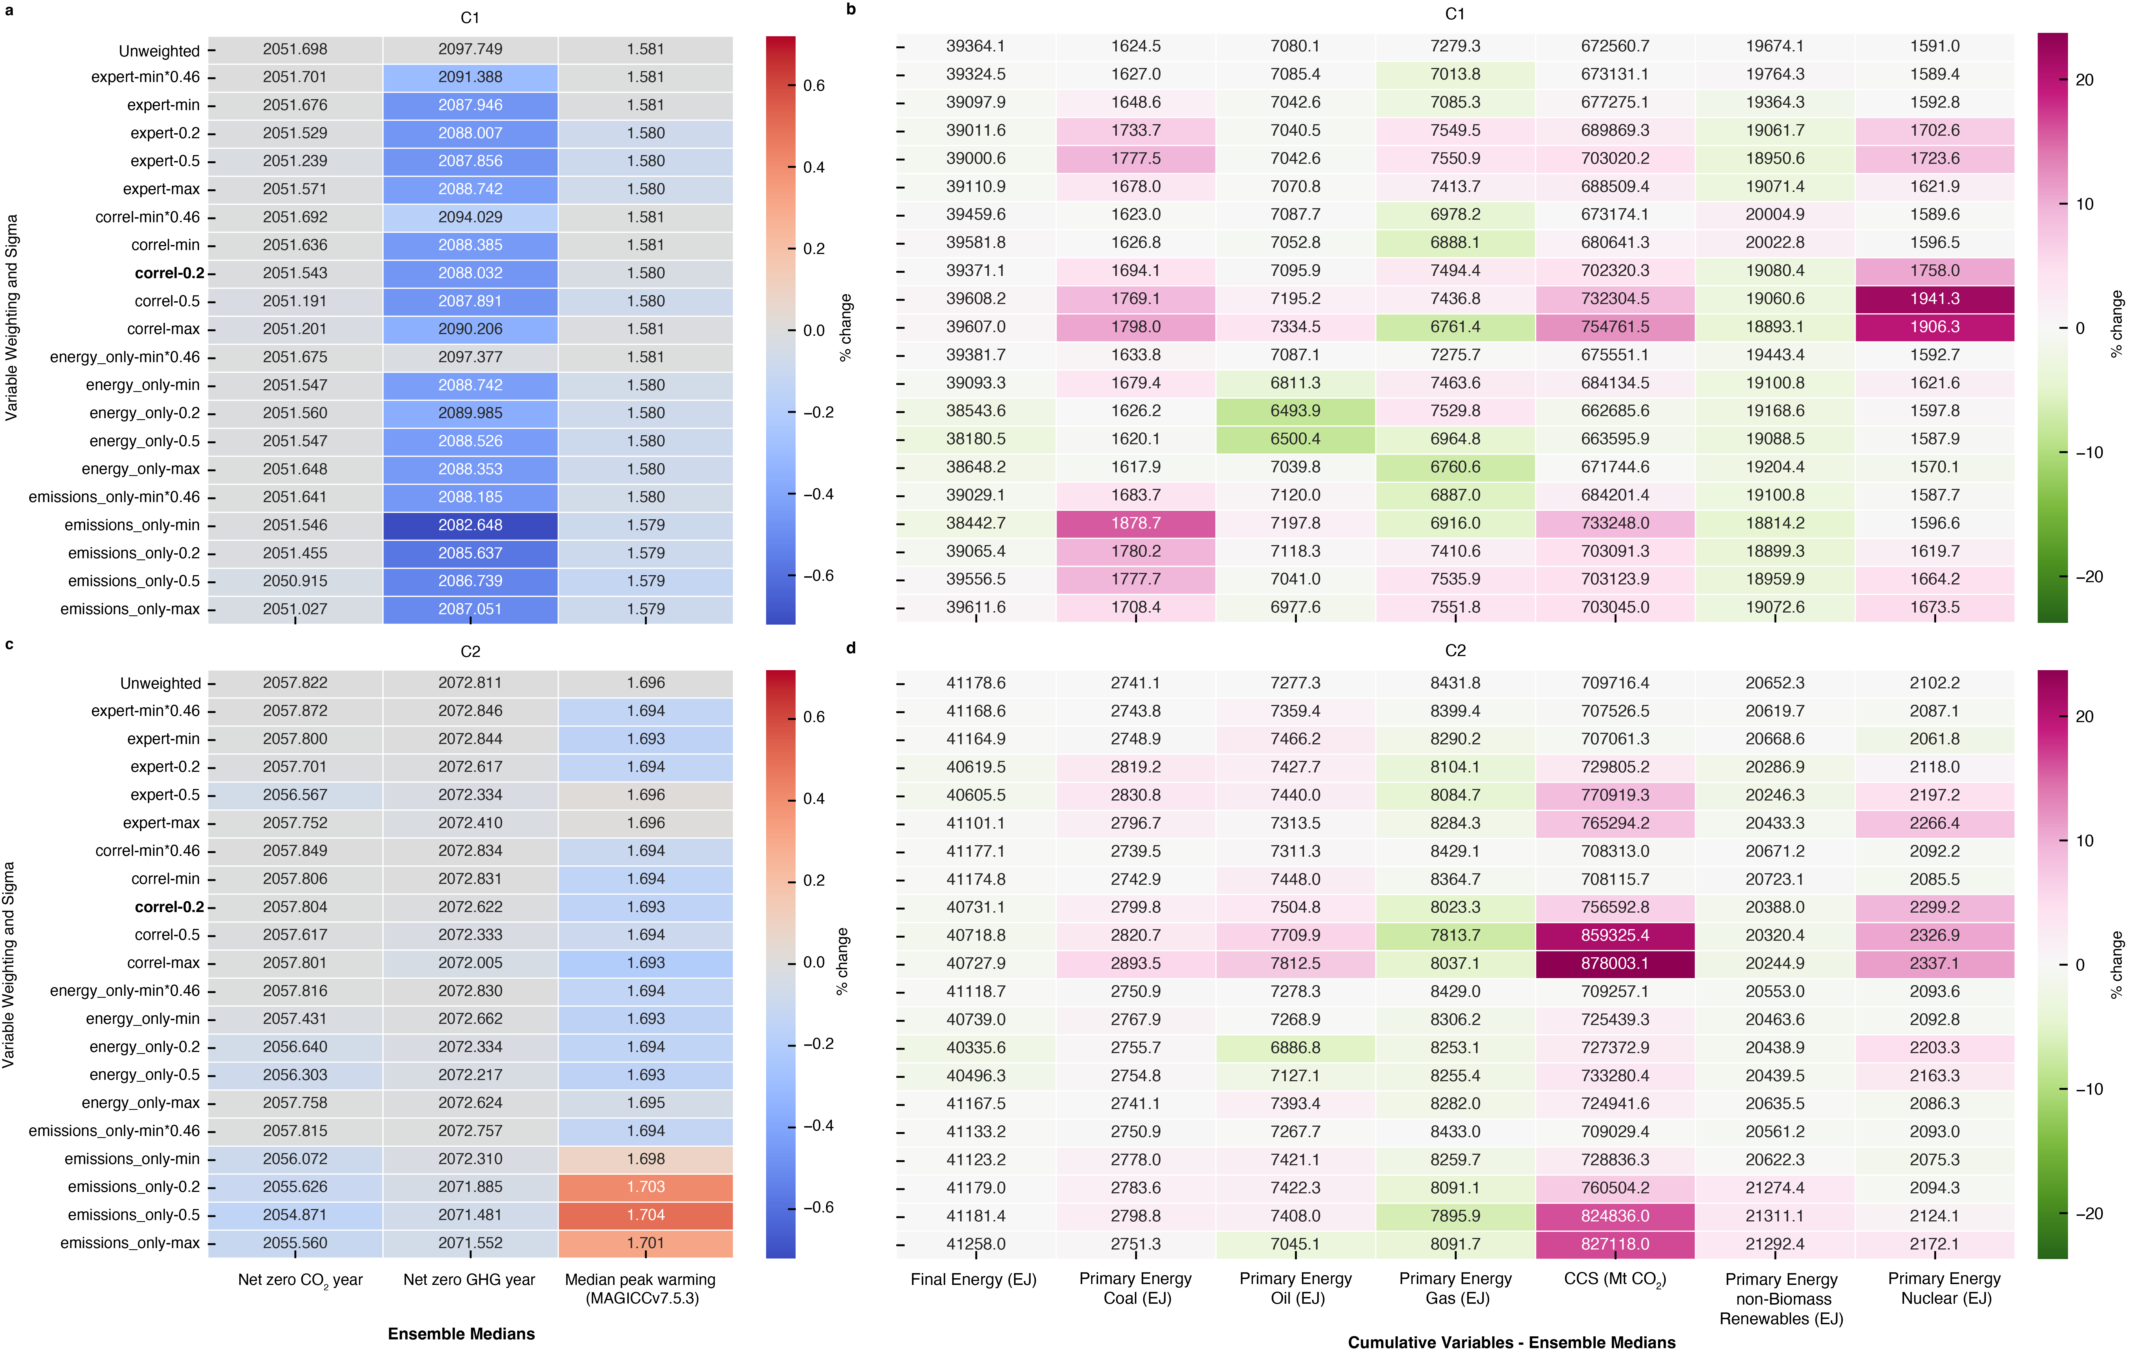

**Supplementary Figure 4** | **Heatmaps showing impact of alternative diversity weighting inputs on ensemble outcomes (medians).** Panel **a** and **c** showing impact on net zero years and peak temperature for C1 and C2 scenarios respectively; panels **b** and **d** showing impact on a range of variables, median values and cumulative 2020-2100 for C1 and C2 scenarios respectively. Cell colours are derived from the % difference from the corresponding unweighted values, shown in the top row. For panels a and c, red denotes increases when compared with unweighted ensemble medians, and blue decreases. For panels b and d, pink = increases and green = decreases when compared with unweighted medians. The results presented in the main paper are identifiable as the bold listed item ‘correl-0.2’ on the x axis. For guidance on weighting inputs see description above in Supplementary Results 2.

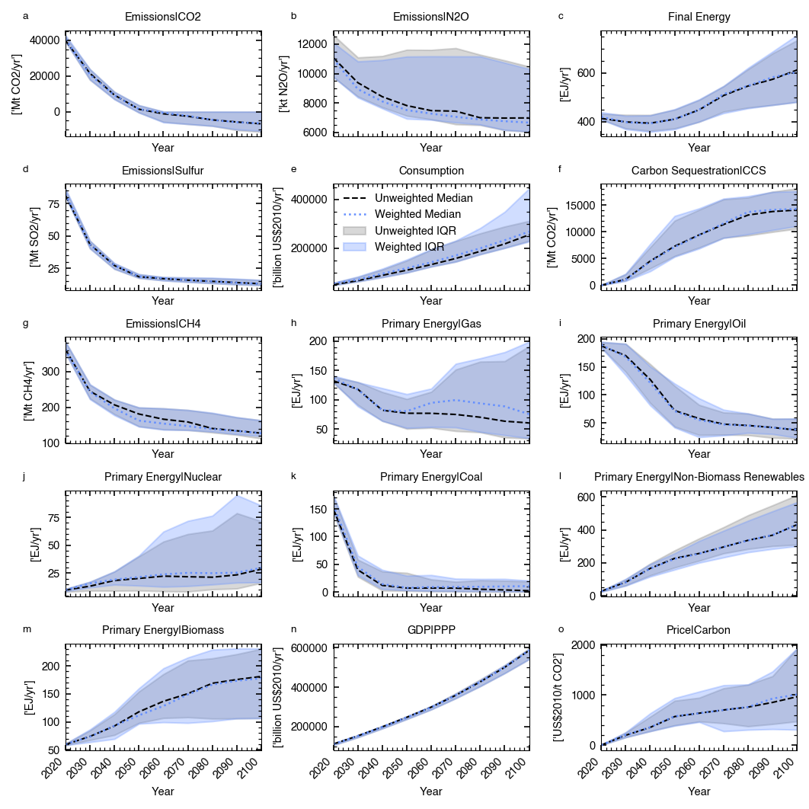

**Supplementary Figure 5 | Timeseries of variables C1 quality reweighted** Panels a-o show each of 15 variables reported by all scenarios, comparing the median and interquartile range for the weighted and unweighted distributions. The black dotted lines represent unweighted medians, the blue dotted lines weighted medians. Grey and coloured shaded areas are the interquartile ranges for the unweighted and weighted distributions, respectively (key shown in panel e, IQR=Interquartile range).

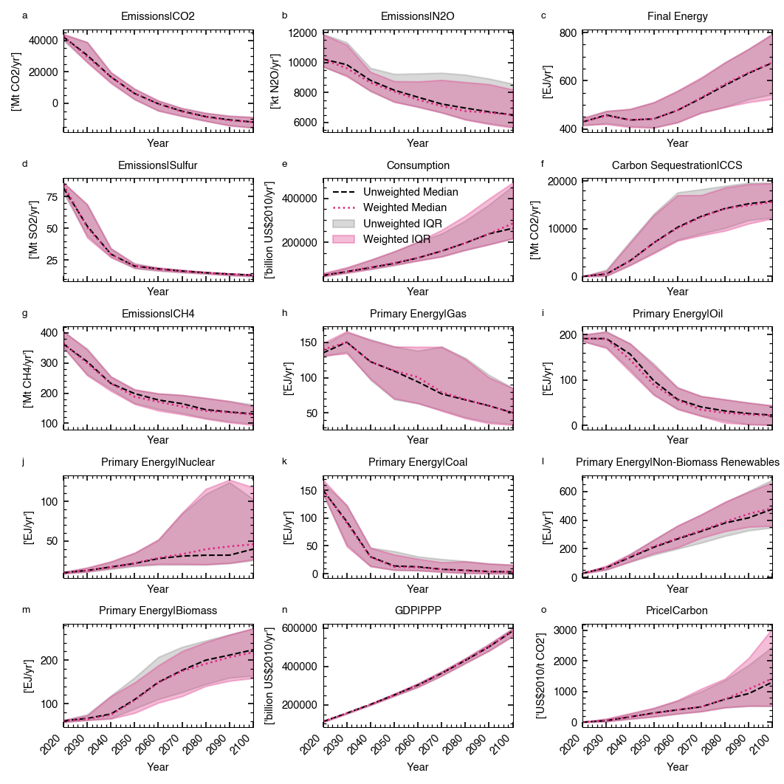

**Supplementary Figure 6 | Timeseries of variables C2 quality reweighted** Panels a-o show each of 15 variables reported by all scenarios, comparing the median and interquartile range for the weighted and unweighted distributions. The black dotted lines represent unweighted medians, the blue dotted lines weighted medians. Grey and coloured shaded areas are the interquartile ranges for the unweighted and weighted distributions, respectively (key shown in panel e, IQR=Interquartile range).

**Supplementary Results 3 | Impact of different sigma values on spread of diversity weights**

The choice for what constitutes scenario similarity is crucial for how the diversity weighting approach operates in practice. Sigma values that are very small relative to ensemble variation, will see only very few scenarios fall within it, this will result in no or minimal reweighting for most scenarios. Conversely, large sigma values relative to ensemble variation will result in scenarios effectively not being reweighted as they are all treated as similar.

Sigma choice will reflect the needs of the user in their application of the weighting procedure. A user may want to implement a specific and known set of sigma values informed by a definition of scenario similarity. This could be guided by distances between certain scenarios. In this context, even if the sigmas are small in relation to ensemble variation, it could be applied as a robustness check across an ensemble. However, an alternative approach is to testing the impact of a range of sigma values with the final choice determined by the impact on the ensemble.

Here, we perform an illustrative example of the latter approach, exploring the impact of a range of sigma values on the spread of weights, by variable. To do this, we stay with our conceptual definition of scenario similarity: the RMS of SSP-RCP combinations, run by different models. We test a range of sigma values between the minimum and the maximum of the SSP-RCP combinations, at 10 percentile intervals to explore the impact on the spread of diversity weights (Supplementary Figure 7). To explore the point at which most variables have seen a collapse in their IQR, we expanded our assessment below the minimum, SSP-RCP model differences testing fractions of the minimum, in a log-spaced grid from 0.1*min to 1*min (6 intervals) (Supplementary Figure 7)



**Supplementary Figure 7 | Impact of sigma values on spread of diversity weights by weighting variable.** Swarm plots showing the interquartile range in the variable-specific diversity weights at a range of sigma values between the maximum and minimum of RMS difference of SSP-RCP combinations run by the same model. Values were taken at 10 percentile intervals and adjusted in tandem with each other. We also show fractions of the minimum, in a log-spaced grid from 0.1*min to 1*min (6 intervals). Median lines shown by grey dotted lines.

As would be expected, the IQR in the diversity weights varies by variable, with the highest median IQR at our 0.46*min set of values (Supplementary Figure 2). The median IQR declines sharply towards the 0.1*min values, however the range increases with some variables (e.g., CH4, N2O) with IQR appearing to be increasing beyond our minimum sigma values. Above the 30th percentile of SSP-RCP model differences, the medians steadily decline, with all variables declining by the max values. Although the maximum median IQR 0.46*min, there is a large range in the IQR values, with some variables, e.g., Carbon Price and CCS where the respective values at this interval have minimal reweighting effect as they are too small. At a higher interval, around the 20th and 30th percentiles, although there is a lower median IQR, the data indicate that all variables are seeing some reweighting. This test of sigma values within a specified range and definition of scenario similarity allows us to stick with the conceptual choice but ensure that the values used will lead to effective reweighting.

Next, taking the diversity weights calculated for each of our variables, before combining, we can explore the impact at the variable level for each set of sigma values. This is important for understanding how sigma values influence each variable and the final reweighted outcomes in the ensemble. Looking at C1 and C2 scenarios (Supplementary Figure 3), we can see that for many variables, regardless of which sigma values used, reweighting would indicate moves likely to represent a strengthening of mitigation action (e.g., more low carbon primary energy and CCS (Supplementary Figure 3, panels j, l, m and f). However, this is not universally true, for example for primary energy from gas and coal, the lower sigma values see the median gas trajectory higher than the unweighted ensemble median.

An important point to recognise is that we perform our diversity weighting and sigma selection across the whole AR6 database. The selection of sigma values to ensure a spread of diversity weights across the ensemble may result in sigma values that have little effect for our subset.



**Supplementary Figure 8 | Impact of sigma values on median timeseries for all C1 and C2 scenarios, applying variables weights to specific variables.** Panels a-o show each of our weighting variables comparing the median of reweighted variables across a range of sigma values, with the unweighted median. Coloured lines represent the reweighted median lines, with the minimum to the maximum of the RCP-SSP model differences shown at each 10 percentile intervals and fractions of the minimum, in a log-spaced grid from 0.1*min to 1*min (6 intervals)

**Supplementary Methods 1 | Calculation of Correlation Adjusted Variable Weights**

Some variables in the database are correlated, meaning that a set of weights might amplify certain signals. Here we perform some simple analysis to derive a set of illustrative variable weights that reduce this effect. To adjust for correlation between our variables, we computed the correlation between our pairs of variables across all vetted scenarios at decadal intervals (2020-2100). We used the mean of the decadal correlations to provide single correlation values for all variable pairs. Variables with correlation above 0.5 are shown in Supplementary Table S4.

**Supplementary Table S4 | Weighting variable pairs with correlations high than 0.6.**

|  |  |
| --- | --- |
| **Pair** | **Correlation** |
| Emissions|CH4 - Emissions|CO2 | 0.756 |
| Emissions|CH4 - Emissions|Sulfur | 0.624 |
| Emissions|CO2 - Final Energy: 0.663 | 0.663 |
| Emissions|CH4 - Primary Energy|Coal | 0.776 |
| Emissions|CO2 - Primary Energy|Coal | 0.801 |
| Emissions|CO2 - Primary Energy|Gas: | 0.659 |
| Emissions|CO2 - Primary Energy|Oil | 0.671 |
| Emissions|Sulfur - Primary Energy|Coal | 0.608 |

The absolute correlations were converted into distance metric (Distance = 1- |correlation|) to be used in the hierarchical clustering process. We used the Scipy hierarchical clustering package to perform clustering [cite]. Clusters were formed using the average linkage method, merging clusters on the mean pairwise distance between cluster members. Looking at clusters between thresholds of 0.4 and 0.5, 0.4 provides only one cluster of more strongly correlated variables, whilst raising the threshold to 0.5 adds further variables to clusters (Supplementary Figure 9 ). We adopt 0.5 for our illustrative use case as it represents greater redundancy removal to be observed in our diversity reweighting results. For each cluster with multiple variables, we select an illustrative variable for each cluster, using the one with the highest weighting in our original weighting scheme. The result is a set of variable weights that reduce redundancy and for variables present, we adopt an even weighting across the variables as we have preserved emphasis on originally higher weighted variables in selection of our representative cluster variables.



**Supplementary Figure 9 I Dendrogram visualising hierarchical clustering of variables.** Colours are used to describe variables that eventually fall into clusters at different distance thresholds. Dotted lines are used to show the difference in clustering at a threshold of 0.4 and 0.5.

**Supplementary Results 4 |** **Impact of diversity weighting on database characteristics and exploration of scenario weights**

Here, we explore how a range of reweighting approaches impact the distribution of projects, model types and model frameworks and policy category.

Firstly, visualising how database characteristics change in unweighted and weighted ensembles, we show a some two examples of weighting procesdures for our 1.5 degrees scenarios and the database as a whole. We show sigma using the 20th percentile of RMS RCP-SSP model differences, identified as having a weighting impact across variables (see Supplementary Results 2). We combine it with our ‘expert’ variable weighting (see Table 1) (Supplementary Figure 4 panels a-c) and our correlation adjusted weighting (panels d-f) (Supplementary Methods 1). For these weighting schemes, there are modest but visible differences in the unweighted and weighted proportions of project, model type and model framework. Although not universal, it appears the reweighting procedure under these conditions results in more balanced representation of project, model type and model frameworks. For example, for all subset examples and both the expert and correlation adjusted weights, we see the REMIND model framework with a reduced share of scenarios. For project representation there is a reduction in the share of the ‘ENGAGE’ project in all but one of our examples. Under our correlation adjusted variable weights, across the whole database, the share of ENGAGE scenarios increases slightly.

Secondly, we test a range of weighting inputs and their impact on the concentration of model frameworks, model types, projects and policy categories. Here we explore the same weighting inputs as in Supplementary Results 2. Although not universal, improvements in project, model framework and model type are robust to a range of alternative inputs for C1 and C2. However, when sigma values are high or low (uneven impact across variables) there are instances where these quantities are worsened. Diversity in scenario policy category is worsened under almost all weighting approaches.



**Supplementary Figure 10 | How diversity reweighting impacts distribution of projects, model types and model frameworks in C1-C8, C1, and C2 scenarios.** Each panel displays the unweighted and weighted proportions of each project, model type and model framework for a subset of scenarios, and for a reweighting procedure. Panels a and d show C1-8 scenarios; panels b and e show C1 scenarios; and panels c and f show C2 scenarios. The top row of panels show sigma of 20th percentile of RCP-SSP model differences, see Supplementary Results 2) with our expert variable weighting. The second row of panels show the same sigma values but with our correlation adjusted variable weighting (see Supplementary Methods 1).

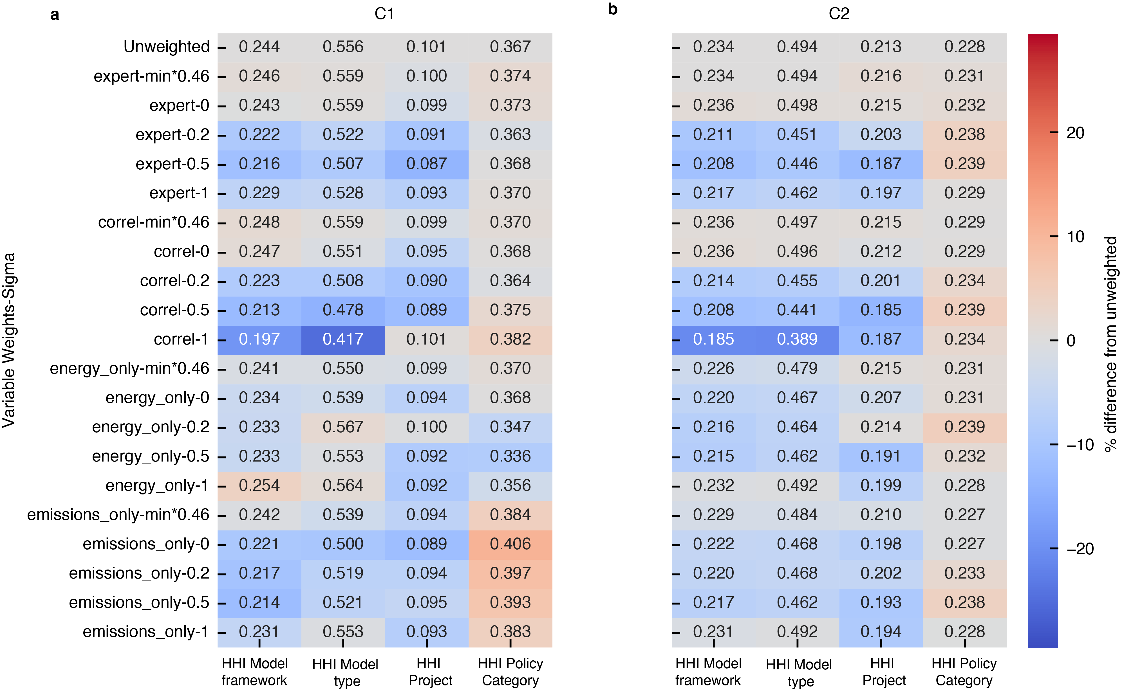

**Supplementary Figure 10 | Heatmaps showing impact of a range of weighting inputs on Herfindahl-Hirschman Index (HHI).** Lower scores indicate improved evenness of model framework, model type, project of policy category. For guidance on weighting examples tested, see Supplementary Results 2. Colours of heatmap cells are based on % difference in HHI value when compared to the unweighted equivalent in the top row. Panel **a** C1 scenarios, and panel **b** C2 scenarios.